We are proud of our ‘Vigor’ members and their achievements:

- Vladimir Kartopoltsev-passed the exam to get the Latvian citizenship in 2014.

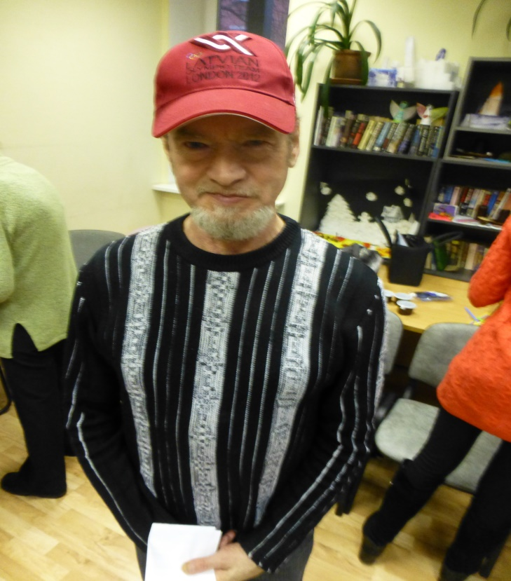

- Taiga Kantane-became a participant of Summer Paralympics in London in 2013.

